29/12/2017



FILTERING ECG SIGNAL

Sıgnal processıng project #2

ANIL Öztürk

14067019

# FILTERING ECG SIGNAL

## THE SOURCE CODE

filename = 'noisy_ecg.mat';

myVars = {'Ts','ecg','fs'};

S = load(filename,myVars{:});

Ts=0.002;

fs=1/Ts;

wm=pi*fs;

wc=2*pi*(40/fs);

n=-30:30;

h=sinc(wc*n/pi)*wc/pi;

figure(1)

t=0:Ts:9.998;

subplot(3,1,1)

plot(t,S.ecg);

xlabel('Time');

ylabel('Amplitude');

y=filtfilt(h,1,S.ecg);

subplot(3,1,2);

plot(t,y);

xlabel('Time');

ylabel('Amplitude');

a=filter(h,1,S.ecg);

subplot(3,1,3);

plot(t,a);

xlabel('Time');

ylabel('Amplitude');

figure(2)

imp = [1; zeros(180,1)];

impresponse_filter=filter(h,1,imp);

b=stem(0:180,impresponse_filter);

xlabel('Samples');

ylabel('Amplitude');

figure(3)

freqz(h);

## THE FILTER COEFFICIENTS

We can get the filter coefficients from the impulse response matrix’ elements. We can obtain them as;

a(0) = 0.0062366

a(1) = 0.00993157

a(2) = 0.0113458

a(3) = 0.009954

a(4) = 0.00589796

a(5) = 3.89975e-17

a(6) = -0.00638946

a(7) = -0.0116851

a(8) = -0.0144401

a(9) = -0.013715

a(10) = -0.00935489

a(11) = -0.00209973

a(12) = 0.00650987

a(13) = 0.0144272

a(14) = 0.019542

a(15) = 0.020182

a(16) = 0.0155642

a(17) = 0.00608927

a(18) = -0.0065967

a(19) = -0.0198089

a(20) = -0.0302731

a(21) = -0.0347413

a(22) = -0.0306577

a(23) = -0.0167397

a(24) = 0.00664913

a(25) = 0.0374196

a(26) = 0.0720038

a(27) = 0.105894

a(28) = 0.134379

a(29) = 0.153347

a(30) = 0.16

a(31) = 0.153347

a(32) = 0.134379

a(33) = 0.105894

a(34) = 0.0720038

a(35) = 0.0374196

a(36) = 0.00664913

a(37) = -0.0167397

a(38) = -0.0306577

a(39) = -0.0347413

a(40) = -0.0302731

a(41) = -0.0198089

a(42) = -0.0065967

a(43) = 0.00608927

a(44) = 0.0155642

a(45) = 0.020182

a(46) = 0.019542

a(47) = 0.0144272

a(48) = 0.00650987

a(49) = -0.00209973

a(50) = -0.00935489

a(51) = -0.013715

a(52) = -0.0144401

a(53) = -0.0116851

a(54) = -0.00638946

a(55) = 3.89975e-17

a(56) = 0.00589796

a(57) = 0.009954

a(58) = 0.0113458

a(59) = 0.00993157

a(60) = 0.0062366

## THE IMPULSE RESPONSE

## FILTERING THE NOISE

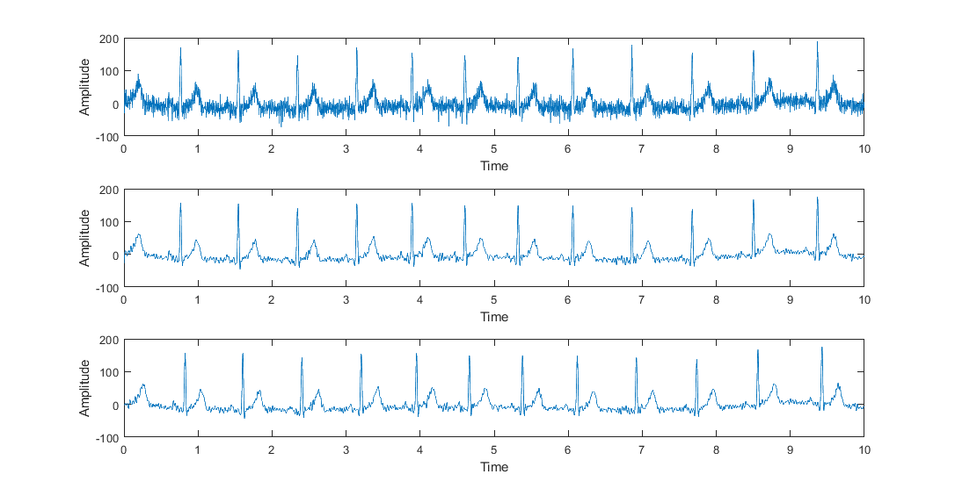The graphs are noisy signal, filtered signal with *filter*, filtered signal with *filtfilt*, respectively.

Filtfilt commands execute a zero-phase filtering when filter command execute normal filtering. Zero-phase filtering can be used for avoiding phase distortion, it’s a noncasual filter. So it can be used for post-processing of stored data, like this ECG signal.

*As we can see, the signal filtered with filtfilt command starts around zero amplitude. We can define the zero-phase filtering algorithm as follows;*

* ***Filter the signal – Time reverse the signal – Filter the signal – Time reverse the signal***

## MAGNITUDE OF THE FREQUENCY SPECTRUM